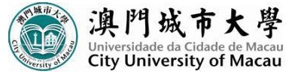

Master Original Project Report
Report Title

Name：

Student No.：

Faculty： Faculty of International Tourism and Management

Program： Master of International Hotel Management

Supervisor：____________________________

Email：

2022-01-01

Resolution of the Defense Committee
Declaration for Originality of Project Report
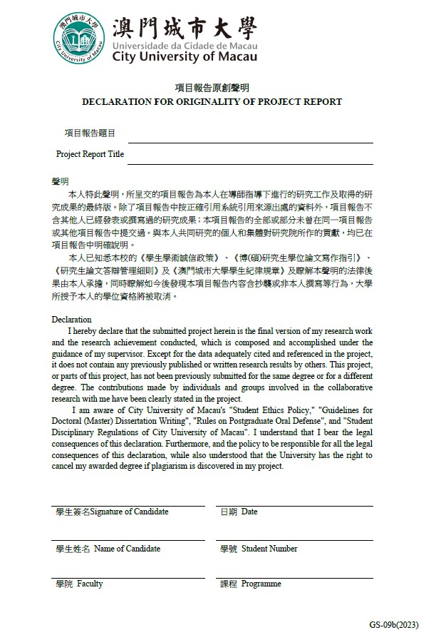
XXX
FITM
YYYY/MM/DD
XXX
MHMEF
必須為電子簽/親筆簽
Acknowlegements

ABC…

Name City University of Macau
2021-01-25

Executive Abstract

Input executive abstract…

Content

List of Figures

Figure One XXXX X

List of Tables

Table One XXXX X

Chapter One Introduction

1.1 XX

1.1.1 XX

Chapter Two XX

2.1 XX

2.1.1 XX

Chapter Three XX

3.1 XX

3.1.1 XX

Chapter Four XX

4.1 XX

4.1.1 XX

4.1.2 XX

4.2 XX

4.2.1 XX

4.2.2 XX

Chapter Five XX

5.1 XX

5.1.1 XX

References
XXX
XXX
對於參考文獻，應注意以下幾點：
l 先列英文文獻，後列中文文獻。英文文獻應依作者姓氏字母順序排列； 中文文獻則按照作者姓氏筆畫或拼音排序均可
l 中文參考文獻不能出現全形的逗號和句號“，”和“。”
l 建議使用Endnote生成參考文獻
l參考文獻下面僅列標準的參考文獻，不要出現和參考文獻無關的中文字樣，也不要人為地為參考文獻分類，如“中文文獻”、“英文文獻”、 “期刊”、“專著”、“圖書”等。出現與參考文獻無關的中文字樣後，會影響論文的查重率
APA格式參考文獻示例：
參考文獻
Akkaya, B., Panait, M., Apostu, S. A., & Kaya, Y. (2022). Agile Leadership and Perceived Career Success: The Mediating Role of Job Embeddedness. International Journal of Environmental Research and Public Health, 19(8).
Bodolica, V., Spraggon, M., & Badi, H. (2021). Extracurricular activities and social entrepreneurial leadership of graduating youth in universities from the Middle East. International Journal of Management Education, 19(2).
Dean, H., & Ford, J. (2017). Discourses of entrepreneurial leadership: Exposing myths and exploring new approaches. International Small Business Journal-Researching Entrepreneurship, 35(2), 178-196.
Khorakian, A., Baregheh, A., Eslami, G., Yazdani, N., Maharati, Y., & Jahangir, M. (2021). Creativity and paternalistic leadership in a developing country's restaurants: The role of job embeddedness and career stage. International
Journal of Tourism Research, 23(4), 677-689.
Rahimnia, F., Nosrati, S., & Eslami, G. (2022). Antecedents and outcomes of job embeddedness among nurses. Journal of Social Psychology, 162(4), 455-470.
Zhang, Y. W., Wu, J. J., & Fan, Y. W. (2022). The Effect of Perceived Organizational Support toward the Environment on Team Green Innovative Behavior: Evidence from Chinese Green Factories. Emerging Markets Finance and Trade, 58(8), 2326-2341.
王玉峰, 趙雯越, & 王樹進. (2022). 差序氛圍感知對員工創新績效的影響研究——個體學習和隱性知識共用的作用. 科技管理研究, 42(05), 121-128.
史慧. (2015). 高校創新人才培養模式研究. (博士). 天津大學.
任迎偉, 張露, & 毛竹. (2021). 工作不安全感與員工創新行為：抑制還是促進. 財經科學(08), 93-105.
宋孜宇, & 高中華. (2020). “張弛有度”方創新有力——教練型領導與員工創新行為關係的雙調節模型. 經濟與管理研究, 41(04), 132-144.
李淵, 曲世友, & 徐峰. (2019). 變革型領導力與員工創新行為模式:基於促進定向的仲介作用. 中國軟科學(07), 125-133.
劉健. (2022). 吸收能力視角下隱性知識共用與產業集聚的互動關係——以物流業為例. 商業經濟研究(10), 105-108.
蔡楊, 石文典, & 陳曉惠. (2019). 員工內外部動機對隱性知識共用意願和創新行為的影響. 心理研究, 12(01), 56-66.

Curriculum Vitae

Education background：
×××××××××
×××××××××

Working experience：
×××××××××
×××××××××

Publications during the period of study：
×××××××××
×××××××××

Appendices

XXXX(Questionnaire/Interview Content)

